MACH4METAL

metalworking machinery
Transito 21,
6909 DA BABBERICH, Netherlands
Tel. + 31 (0)316 – 247123
Fax. + 31 (0)316 - 247956

Bank No : 66.52.13.883
IBAN : NL33 INGB 0665 2138 83
BIC : INGBNL2A
info@mach4metal.com www.mach4metal.com www.mach4metal.com

GILDEMEISTER NEF 710 x 2000 mm
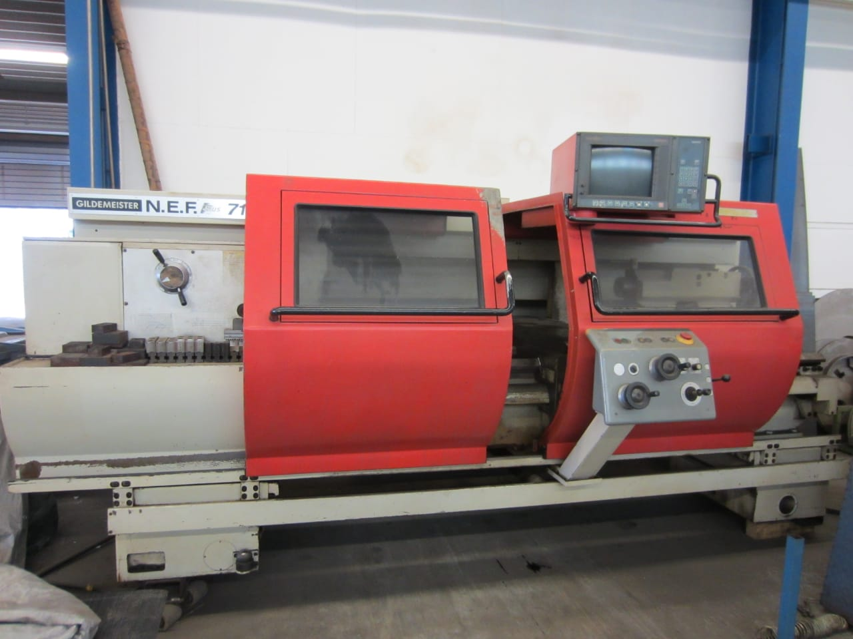

- Make : Gildemeister
- Type : NEF Plus 710
- Age : 505 004
- Mach. No. :

- Max. turning Ø bed : 760
- Max. turning Ø carriage : 420
- Centre height : 380
- Centre distance : 2.000

- Spindle bore : 92
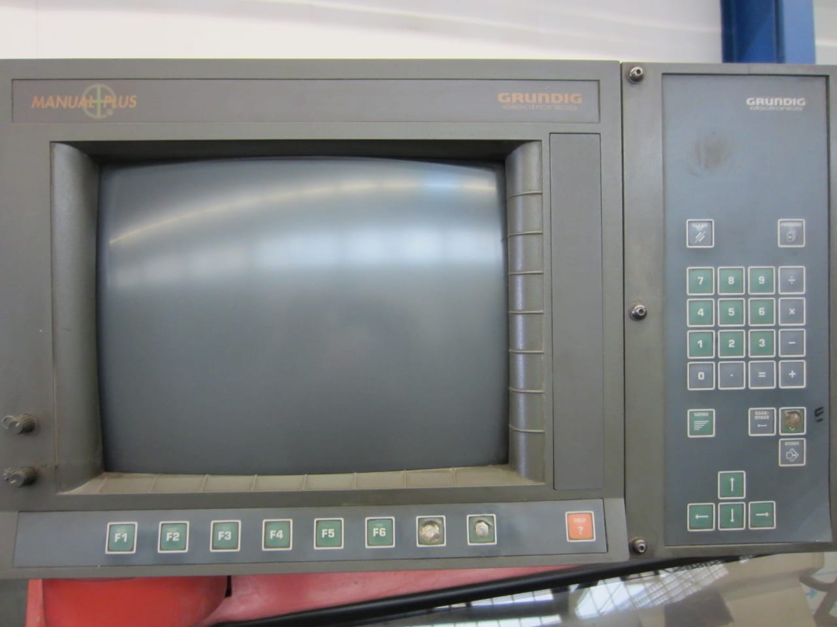
- Speeds 3 ranges : 1.800

- Pinole Ø : 110
- Stroke pinole : 210
- Work load Kg :

- Dimensions:
- Length : 4.250
- Width : 2.200
- Height : 1.900
- Weight : 5.600 Kg
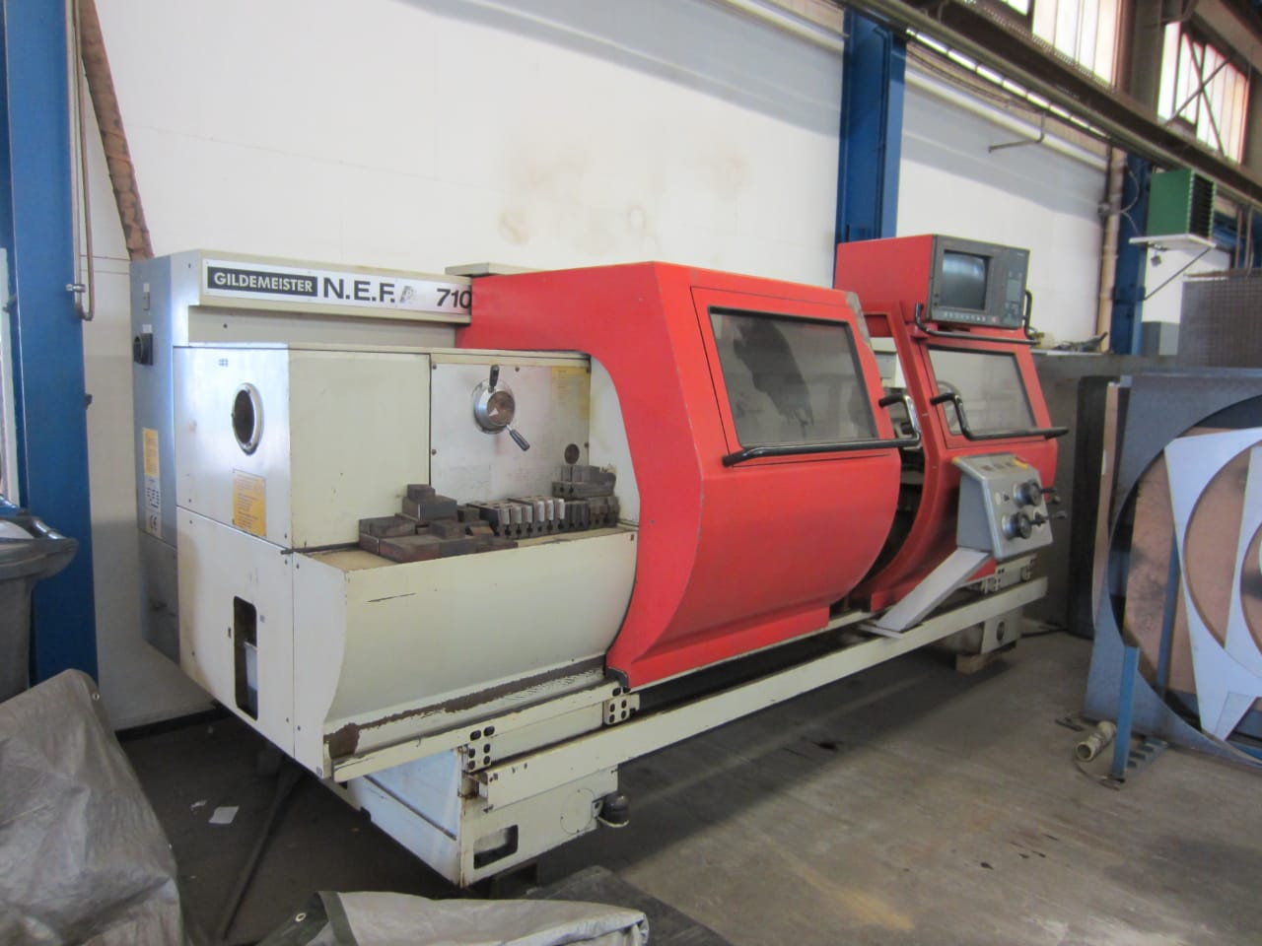

- MANUEL PLUS
- CE safety doors / covers
- Chuck Ø
- Tool system

- Steady rest
- Coolant system

Please Note: The above information has been obtained to the best of our ability and belief from, and from the manufacturers where possible. It is given in good faith, but its accuracy can not be guaranteed. Accordingly, it will not form a representation or constitute contractual terms. We advise you to check any vital details !

